LABOROTORIYA ISHI №15
Mavzu: Websocket orqali oddiy real vaqt chat ilovasi yaratish.
Ishning maqsadi
- WebSocket protokolining ishlash tamoyillarini o'rganish.
- An'anaviy HTTP so'rovlari va WebSocket aloqasi o'rtasidagi farqni tushunish.
- Real vaqt rejimida xabar almashuvchi chat interfeysini yaratish.
Nazariy qism
WebSocket nima?
WebSocket — bu bitta TCP ulanishi orqali uzoq muddatli, ikki tomonlama aloqa kanalini ta'minlovchi kompyuter aloqa protokolidir. HTTP protokoli "so'rov-javob" (request-response) modelida ishlasa, WebSocket ulanish ochiq turganda server mijozga istalgan vaqtda so'rovsiz ma'lumot yubora olishiga imkon beradi.
Ishlash mexanizmi (Handshake)
WebSocket aloqasi HTTP orqali boshlanadi. Mijoz serverga "Upgrade: websocket" sarlavhasi bilan so'rov yuboradi. Agar server buni qo'llab-quvvatlasa, ulanish WebSocket rejimiga o'tadi va HTTP yopiladi. Shundan so'ng ma'lumotlar kichik freymlarda, juda kam kechikish (latency) bilan uzatiladi.
Asosiy metodlar
Dasturlashda WebSocket bilan ishlash uchun quyidagi hodisalardan foydalaniladi:
- onopen: Ulanish muvaffaqiyatli o'rnatilganda ishga tushadi.
- onmessage: Serverdan yangi xabar kelganda chaqiriladi.
- onsend: Ma'lumotlarni serverga yuborish uchun ishlatiladi.
- onclose: Ulanish uzilganda xabar beradi.
Amaliy qism:
<!DOCTYPE html>
<html lang="uz">
<head>
<meta charset="UTF-8">
<meta name="viewport" content="width=device-width, initial-scale=1.0">
<title>Real-Time Chat - WebSocket Lab</title>
<link href="https://fonts.googleapis.com/css2?family=Inter:wght@300;400;600&display=swap" rel="stylesheet">
<link rel="stylesheet" href="https://cdnjs.cloudflare.com/ajax/libs/font-awesome/6.0.0/css/all.min.css">
<style>
:root {
--chat-bg: #f4f7f6;
--primary: #0088cc; /* Telegram ko'k rangi */
--white: #ffffff;
--text: #333;
}
body {
font-family: 'Inter', sans-serif;
background-color: #e5ddd5; /* Chat fon rangi */
margin: 0;
display: flex;
justify-content: center;
align-items: center;
height: 100vh;
}
.chat-container {
width: 400px;
height: 600px;
background: var(--white);
border-radius: 15px;
display: flex;
flex-direction: column;
box-shadow: 0 10px 25px rgba(0,0,0,0.1);
overflow: hidden;
}
/* Chat Header */
.chat-header {
background: var(--primary);
color: white;
padding: 15px;
display: flex;
align-items: center;
gap: 10px;
}
.chat-header img {
width: 40px;
height: 40px;
border-radius: 50%;
background: #eee;
}
.status-dot {
width: 10px;
height: 10px;
background: #4caf50;
border-radius: 50%;
border: 2px solid white;
}
/* Xabarlar maydoni */
.messages-area {
flex: 1;
padding: 20px;
overflow-y: auto;
background: url('https://user-images.githubusercontent.com/15075759/28719144-86dc0f70-73b1-11e7-911d-60d70fcded21.png');
display: flex;
flex-direction: column;
gap: 10px;
}
.message {
max-width: 80%;
padding: 10px 15px;
border-radius: 15px;
font-size: 0.9rem;
position: relative;
}
.message.sent {
align-self: flex-end;
background: #dcf8c6;
border-bottom-right-radius: 2px;
}
.message.received {
align-self: flex-start;
background: var(--white);
border-bottom-left-radius: 2px;
}
.time {
font-size: 0.7rem;
color: #888;
display: block;
text-align: right;
margin-top: 5px;
}
/* Input qismi */
.input-area {
padding: 15px;
background: #f0f0f0;
display: flex;
gap: 10px;
}
input {
flex: 1;
border: none;
padding: 10px 15px;
border-radius: 20px;
outline: none;
}
.btn-send {
background: var(--primary);
color: white;
border: none;
width: 40px;
height: 40px;
border-radius: 50%;
cursor: pointer;
transition: 0.3s;
}
.btn-send:hover { transform: scale(1.1); }
</style>
</head>
<body>
<div class="chat-container">
<div class="chat-header">
<img src="https://ui-avatars.com/api/?name=Xiva+Guide&background=random" alt="User">
<div style="flex: 1;">
<div style="font-weight: 600;">Xiva Live Chat</div>
<div style="font-size: 0.8rem; opacity: 0.8;">Online</div>
</div>
<div class="status-dot"></div>
</div>
<div class="messages-area" id="chatBox">
<div class="message received">
Xush kelibsiz! WebSocket orqali real vaqtda bog'landingiz.
<span class="time">10:00</span>
</div>
</div>
<div class="input-area">
<input type="text" id="msgInput" placeholder="Xabar yozing..." onkeypress="handleKey(event)">
<button class="btn-send" onclick="sendMessage()">
<i class="fas fa-paper-plane"></i>
</button>
</div>
</div>
<script>
function sendMessage() {
const input = document.getElementById('msgInput');
const chatBox = document.getElementById('chatBox');
if (input.value.trim() === "") return;
// Xabarni ekranga chiqarish (Sent)
const msgDiv = document.createElement('div');
msgDiv.className = 'message sent';
const now = new Date();
msgDiv.innerHTML = `${input.value} <span class="time">${now.getHours()}:${now.getMinutes()}</span>`;
chatBox.appendChild(msgDiv);

// Avtomatik javob simulyatsiyasi (WebSocket Serverdan kelgan xabar kabi)
setTimeout(() => {
const replyDiv = document.createElement('div');
replyDiv.className = 'message received';
replyDiv.innerHTML = `Server: Xabaringiz qabul qilindi! <span class="time">${now.getHours()}:${now.getMinutes()}</span>`;
chatBox.appendChild(replyDiv);
chatBox.scrollTop = chatBox.scrollHeight;
}, 1000);
input.value = "";
chatBox.scrollTop = chatBox.scrollHeight;
}
function handleKey(e) {
if (e.key === 'Enter') sendMessage();
}
</script>
</body>
</html>
Natijasi:

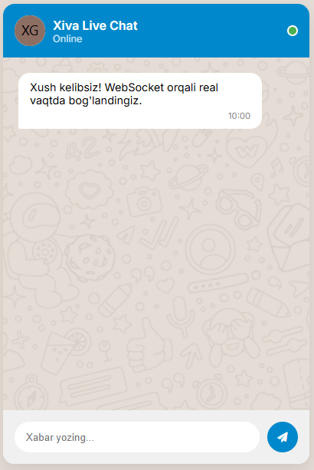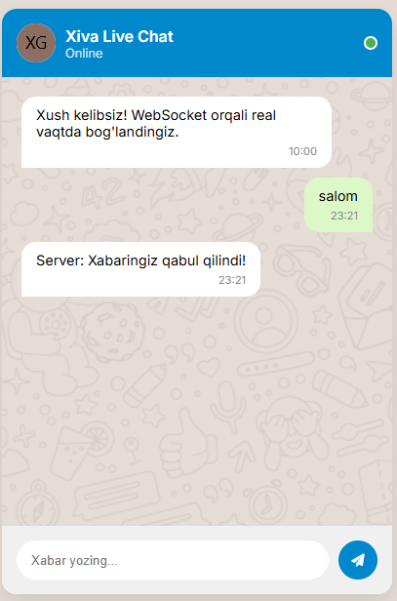
Xulosa:
WebSocket texnologiyasini o'rganish davomida quyidagi xulosalarga kelindi:
Tezkorlik: WebSocket HTTP'ga qaraganda real vaqt rejimidagi ma'lumotlar uchun ancha samarali, chunki har safar yangi sarlavhalar (headers) yuborilmaydi.
Ikki tomonlama aloqa: Serverning mijozga "itariuvchi" (push) xabarlarni yubora olishi chat ilovalari uchun eng katta afzallikdir.
Amaliylik: Ushbu protokol yordamida nafaqat chatlar, balki ko'p foydalanuvchili tahrirlash asboblari va real vaqtda kuzatish tizimlarini yaratish mumkin.

